

Dealer-in-a-box
开发手册Developer’s Guide
--接口文档 Interface Document

编 写Write |  |  |  |  | 编写 时间Writing Time
审 核  Check | 审核者姓名（及其职务）Checker Name (Position) |  |  |  | 审核 时间  Checking Time
审 批  Approve | 审批者姓名（及其职务）Approver Name(Position) |  |  |  | 审批 时间  Approving Time
文档管理  Document Management | 页码  Page No. | 共 页  Total Pages | 修订次数  Revise Times | 共 次  Total Times |  | 版本  Version |  | V1.0
文档管理  Document Management | 编号No.

亚信联创科技（中国）有限公司版权所有
Asiainfo-Linkage, Inc. All Right Reserved
文档中的全部内容属亚信联创科技（中国）有限公司所有，
未经允许，不可全部或部分发表、复制、使用于任何目的。
All the Contents in the Document Belong to Asiainfo-Linkage, Inc.,
And Without Approval, Can not be Entirely or Partly Published, Copied or Used for any Purposes.
文档修订摘要Document Revise Abstract

日期Date | 修订号  Revise No. | 描述Descrpition | 著者  Author | 审阅者  Checker | 批准人/日期  Approver/Date
2014-04-24 | V0.9 | 新建New

1.1 主要流程 Main Processes 1
1.1.1 开户 Register 1
1.1.2 充值 Top up 3
1.1.3 产品订购 Add-on 4
1.2 请求方式 Request Mode 4
1.3 报文格式 Message Format 4
1.4 请求接口包体(body) Request Interface Body 5
1.4.1 YD9001合约计划更新 Contract Plan Updating 5
1.4.2 YD0002 号码预占No. Reservation 7
1.4.3 YD9003终端信息和预览图片更新 Mobile Info. And Preview Image Updating 7
1.4.4 YD9004套餐信息更新 Package Info. Updating 8
1.4.5 YD0005算费 Billing 9
1.4.6 YD0006注册接口 Register Interface 10
1.4.7 YD0007 用户信息查询 User Info. Inquiry 11
1.4.8 YD0008 号码搜索 No. Search 11
1.4.9 YD0009充值 Top up 12
1.4.10 YD0010开户订单 New User Order 13
1.4.11 YD0011 订购商品信息列表 Ordered Product Info. List 14
1.4.12 YD0012订购商品 Order Product 14
1.4.13 YD0013代理商账户充值接口 Dealer Top-up Interface 15
1.4.14 YD0014佣金实时导入接口（暂时不用）Commission Real-time Collection Interface(Not Available) 15
1.4.15 YD9015 订购库存商品订单回调（TIBCO配货完成回调）Inventory Goods Order Callback(TIBCO Distribution Callback) 16
1.4.16 YD0016叠加包的下单接口 Add-on Package Order Interface 17
1.4.17 YD0017 佣金文件批量导入 Commission File Batch Import 17
1.4.18 YD0018 短信接口 SMS Interface 18

主要流程
1.1 Main Processes

开户
1.1.1 New User
普通合约开户（没有终端）
Ordinary Contract New User (without Mobile)

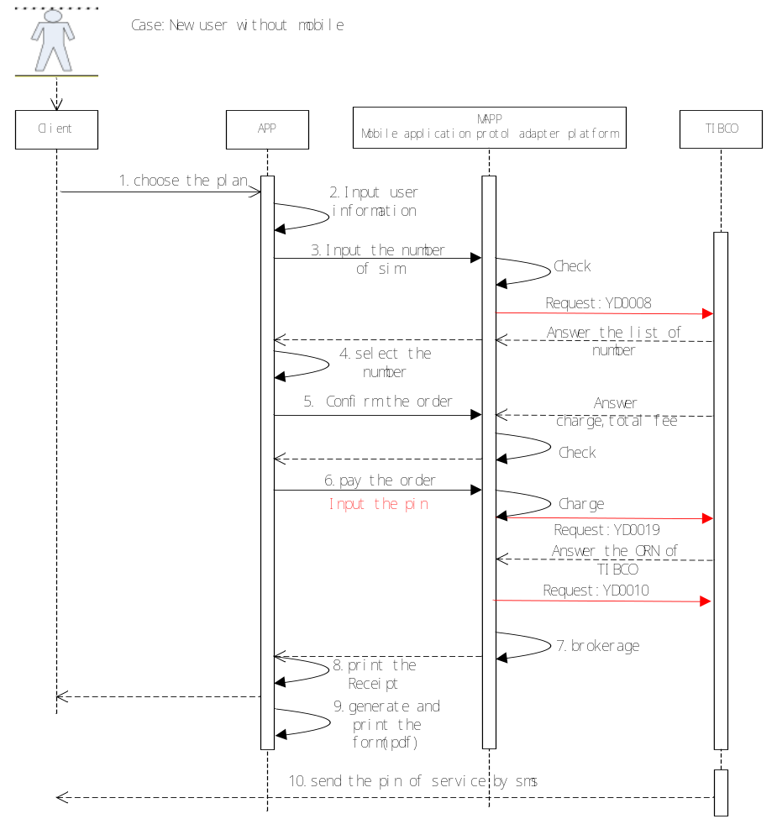

调用接口
Call Interface
YD0008，YD0005，YD0010

普通开户（带终端）
Ordinary New User(with Mobile)
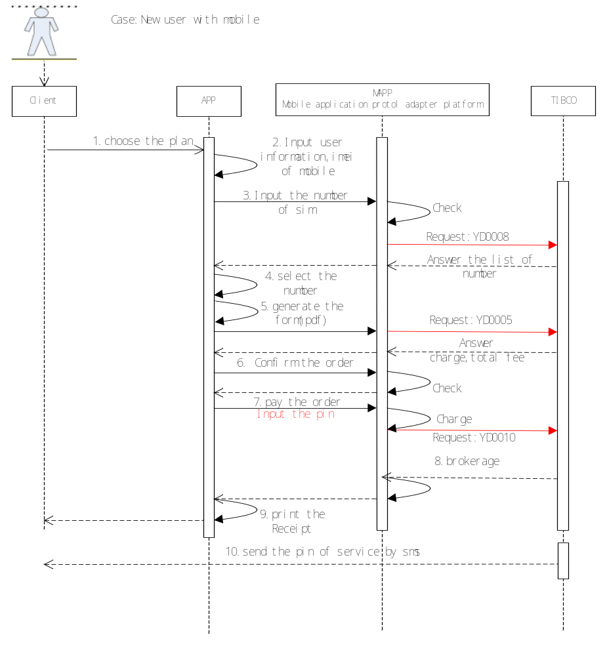
调用接口
Call Interface
YD0008，YD0005，YD0010

充值
1.1.2 Top up
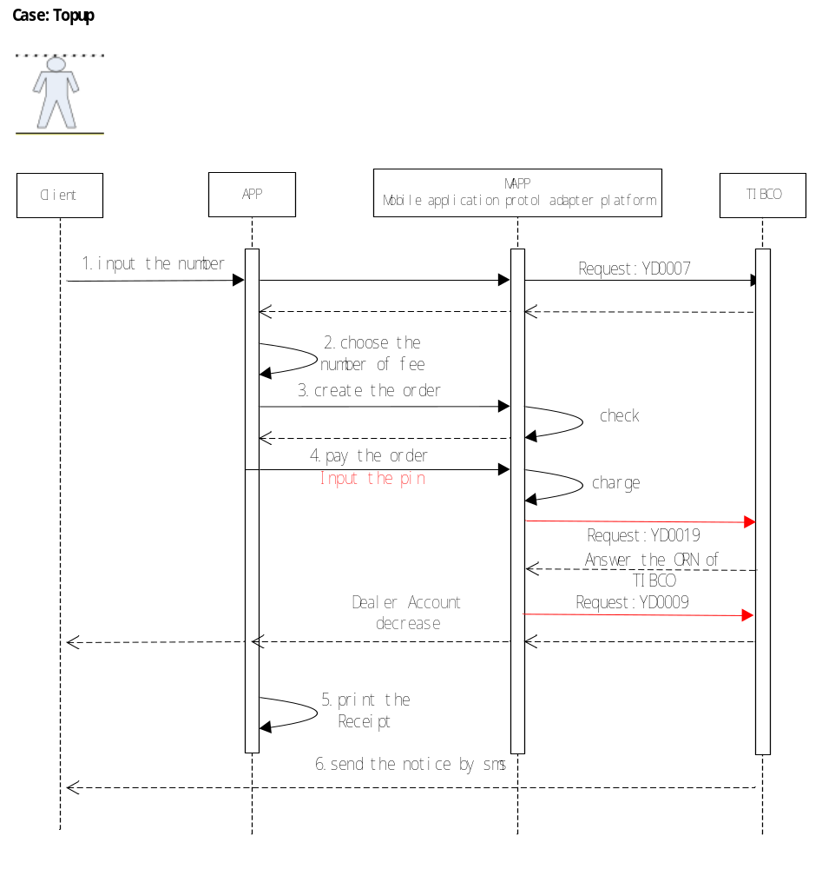
调用接口
Call Interface
YD0007，YD0009

产品订购
1.1.3 Add-on
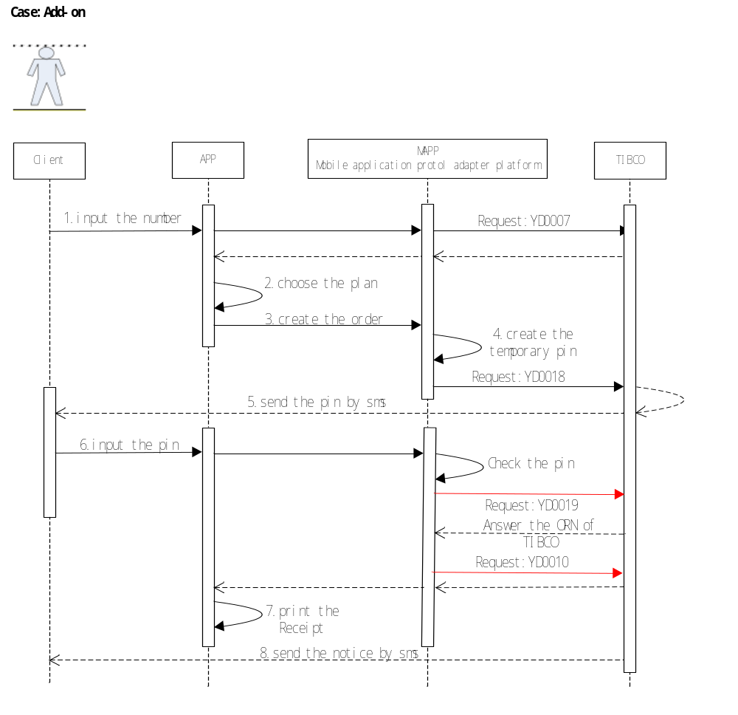
调用接口
Call Interface
YD0007，YD0018，YD0016

请求方式
1.2 Request Mode
接口请求方式 http+json的方式请求，例如：
Interface Request Mode, such as:
请求连接格式：http://[ip]:[port]/[web_name]/mapp/json.do?msg=[param]
Request Connection Mode:
ip：请求地址
port：请求端口
web_name:应用部署的名称
param:请求参数，以json的格式传输 transmit in the form of json

所有接口对接统一接口平台
Uniform Interface Platform

报文格式
1.3 Message Format
报文整体是
Message Body
{
"@class": "com.ailk.ts.mapp.model.TSDatapackage",
"header": {
"@class": "com.ailk.ts.mapp.model.TSHeader",
"bizCode": null,
"identityId": null,
"coordinates": null,
"respCode": null,
"respMsg": null,
"mode": null,
"sign": null
},

"body": {报体内容}
}

报文格式
Message Format
节点名称  Name of the nod | 父节点  Parent nod | 约束  Constraint | 类型  type | 说明  description
@class |  | 1 | String | 值: com.ailk.yd.mapp.model.YDDatapackage Value
header |  | 1 | String | 终端ID Phone ID
@class | header | 1 | String | 值:com.ailk.yd.mapp.model.YDHeader Value
bizCode | header | 1 | String | 请求接口 Request Interface
identityId | header | 1 | String | 流水 Serial No.
coordinates | header | 1 | String | 坐标（有地图应用时使用）Coordinates (used with map apps)
respCode | header | 1 | String | 响应编码：0000表示成功，其他表示异常respond code: 0000 is success. Others are abnormal.
respMsg | header | 1 | String | 响应信息Respond Message
mode | header | 1 | String | 模式：0表示无需签名验证，1表示验证签名Mode: 0 shows no need for signature verification. 1 shows the need for signature verification.
sign | header | 1 | String | 签名信息Signing message
token | header | 1 | String | 令牌Token
body |  | 1 | String | 请求内容Request Body

请求接口包体(body) Request Interface Body

YD9001合约计划更新 Contract Plan Updating

请求端Requester | TIBCO
服务端Server | Dealer系统Dealer System
接口作用Interface Effect | 更新dealer数据库中可以在手机端销售的合约计划以及叠加包的信息  Update the information of the contract plan and add-on package which can be sold on mobiles in the dealer database

参数：
Parameter:
optype | 0 新增，1修改，2删除 0 New 1 Modify 2 Delete
payType | 0 预付费，1后付费 0 Pre-payment 1 Post-payment
productType | 0 预付费，1,带终端后付费 ，2，后付费 sim，3 data-sim 9是add-on套餐  0 pre-payment, 1 Post-payment with phones, 2 Post-payment SIM, 3 data-sim,9 add-on packages
recommend | 0 不推荐，1 推荐 0 Not Recommend, 1 Recommend

业务代码：
bizCode： YD9001
请求报体：
Request Message:
节点名称Name of the Nod |  | 父节点Parent Nod |  | 约束Constraint |  | 类型  Type |  | 说明  Description
product |  | body |  | ? |  | List<Product> |  | 合约计划类表Contract Plan List
optype |  | product |  | 1 |  | String |  | 操作类型，0 新增，1修改，2删除Operation Type, 0 New, 1 Modify, 2 Delete
phoneId |  | product |  | 1 |  | String |  | TIBCO的终端ID TIBCO’s Phone ID
model |  | product |  | 1 |  | String |  | 终端型号 Phone Model
pic |  | product |  | 1 |  | String |  | 终端列表图片 Phone List Picture
term |  | product |  | 1 |  | String |  | 合约期数 （0非合约，12期，24期，36期）Contract Term (0 no contract, 12 terms, 24 terms, 36 terms)
productId |  | product |  | 1 |  | String |  | 合约ID Contract ID
actType |  | product |  | 1 |  | String |  | 合约类型 Contract Type
title |  | product |  | 1 |  | String |  | 合约标题 Contract Title
price |  | product |  | 1 |  | BigDecimal |  | 合约价格 Contract Price
preStore |  | product |  | 1 |  | BigDecimal |  | 合约预存款 Contract Pre-deposit
backMonth |  | product |  | 1 |  | BigDecimal |  | 每月返还Monthly Return
resFee |  | product |  | 1 |  | BigDecimal |  | 终端价格Phone Price
allFee |  | product |  | 1 |  | BigDecimal |  | 该套餐返还总费用All Returned Fee of Packages
productFee |  | product |  | 1 |  | BigDecimal |  | 月保底消费Product Fee
contractId |  | product |  | 1 |  | String |  | 套餐id Package ID
recommend | product |  | 1 |  | String |  | 是否推荐 0 不推荐，1 推荐Recommend 0 no 1 yes
payType |  | product |  | ? |  | String |  | 类型：0 预付费，1,带终端后付费 ，2，后付费 sim，3 data-sim 都是不带终端的 9是add-on套餐Type: 0 Pre-payment, 1 Post-payment with phones, 2 Post-payment SIM, 3 data-sim without phones,9 bolt-on packages
validTime |  | product |  | ? |  | String |  | 生效时间
invalidTime |  | product |  | ? |  | String |  | 失效时间

eg:
{"@class":"com.ailk.yd.mapp.model.YDDatapackage","header":{"@class":"com.ailk.yd.mapp.model.YDHeader","bizCode":"9001","identityId":"86590","respCode":null,"respMsg":null,"mode":"update","sign":"qdwrfgxjdhyrtyfb"},"body":{"@class":"com.ailk.yd.mapp.model.YD9001.YD9001Request","productList":[{"@class":"com.ailk.yd.mapp.model.YD9001.YD9001Request$Product","optType":"0","phoneId":"192.168.1.109","brand":"iphone","model":"4s","pic":"/pics/iphone/4s.jgp","term":"24","contactType":"B","productId":"998","actType":"actType","title":"iphone 4s 8G","price":4880,"preStore":360,"backMonth":"backMonth","resFee":286,"allFee":886,"productFee":99,"contractId":"1999","recommend":"1","payType":"1","productType":"productType"}]}}

应答报体：Respond Message
无None

eg：

YD0002 号码预占 No. Reservation

请求端Requester | Dealer系统Dealer System
服务端Server | TIBCO
接口作用Interface Effect | 在选号完成时，先将号码进行预占 ，以防止别的dealer重复选择该号码  After selecting a No., reserve the No. so that other dealers can not choose this No.

参数：Parameter
无None
业务代码：
bizCode： YD0002
请求报体：Request Message
节点名称  Name of the Nod | 父节点Parent Nod | 约束Constraint | 类型Type | 说明  Description
dealerid | body | 1 | Long | 预占的代理商Dealer ID
orn | body | 1 | String | 从Tibco获取的orn
mdn | body | 1 | String | 选取的号码Selected No.

eg:
{"@class":"com.ailk.yd.mapp.model.YDDatapackage","header":{"@class":"com.ailk.yd.mapp.model.YDHeader","bizCode":"YD0002","identityId":"86590","respCode":null,"respMsg":null,"mode":"1","sign":""},"body":{"@class":"com.ailk.yd.mapp.model.YD0002.YD0002Request","dealerid":4599,"mdn":"18605710571","orn":"OT1000001" }}

应答报体：No Response Message
{"@class":"com.ailk.yd.mapp.model.YDDatapackage","header":{"@class":"com.ailk.yd.mapp.model.YDHeader","bizCode":"yd0002","identityId":"1401390292276","respCode":"0000","respMsg":null,"mode":null,"sign":null},"body":null}

YD9003 终端信息和预览图片更新 Mobile Info. And Preview Image Updating

请求端Requester | TIBCO
服务端Server | Dealer系统
接口作用Interface Effect | 更新dealer数据库中手机的相关信息  Update the phone’s relevant Information in the dealer database

参数：parameter

optype | 0 新增，1修改，2删除 0 New 1 Modify 2 Delete

业务代码：
bizCode： YD9003
请求报文：Request Message
节点名称  Name of the Nod | 父节点Parent Nod | 约束Constraint | 类型  Type | 说明  Description
phoneList | body | ? | List<Phone> | 终端列表
phoneId | phoneList | 1 | String | 终端ID Phone ID
model | phoneList | 1 | String | 型号Model
ifInt | phoneList | 1 | String | 是否智能If Intelligent?
exterior | phoneList | 1 | String | 外观Exterior
os | phoneList | 1 | String | 操作系统Operating System
network | phoneList | 1 | String | 网络频段Network Frequency Band
trans | phoneList | 1 | String | 数据传输Data Transmission
browser | phoneList | 1 | String | 浏览器Browser
memory | phoneList | 1 | String | 内存Memory
extraMemory | phoneList | 1 | String | 扩展内存Extra Memory
screen | phoneList | 1 | String | 屏幕尺寸Screen Size
isWideScreen | phoneList | 1 | String | 是否宽屏Is Wide Screen?
screenType | phoneList | 1 | String | 屏幕类型Screen Type
resolution | phoneList | 1 | String | 分辨率Resolution
musicType | phoneList | 1 | String | 音频格式Music Type
videoFormat | phoneList | 1 | String | 视频格式Video Format
batterySpace | phoneList | 1 | String | 电池容量Battery Space
gps | phoneList | 1 | String | 是否Gps GPS?
blue | phoneList | 1 | String | 是否蓝牙Blue?
brand | phoneList | 1 | String | 品牌Brand
instructions | phoneList | 1 | String | 相关配件Relevant Accessories
image | phoneList | * | Map<String,String> | 图片节点Image Nod
url | Image-key | 1 | String | 商品信息图片URL Good Info. Image URL
orgiUrl | Image-value | 1 | String | 商品信息图片URL Good Info. Image URL
optype | product | 1 | String | 操作类型，0 新增，1修改，2删除Operation Type, 0 New, 1 Modify, 2 Delete
batteryType | phoneList | ? | String | 电池类型
color | phoneList | ? | String | 颜色

应答报文：Respond Message
无 Return No Message

模板： Template

eg:
{"@class":"com.ailk.yd.mapp.model.YDDatapackage","header":{"@class":"com.ailk.yd.mapp.model.YDHeader","bizCode":"YD9003","identityId":"86590","respCode":null,"respMsg":null,"mode":"update","sign":"qdwrfgxjdhyrtyfb"},"body":{"@class":"com.ailk.yd.mapp.model.YD9003.YD9003Request","phoneList":[{"@class":"com.ailk.yd.mapp.model.YD9003.YD9003Request$Phone","phoneId":"192.168.1.109","model":"model","ifInt":"Y","exterior":"exterior","os":"mac","network":"network","trans":"trand","browser":"chrome","memory":"512","extraMemory":"156","screen":"1024*768","isWideScreen":"Y","screenType":"crt","resolution":"resolution","musicType":"mp3","videoFormat":"mp4","batterySpace":"999","gps":"10.10.10.10","blue":"bule","brand":"apple","instructions":"ins","imgInfoList":[{"pic1":"/pics/pic1","pic2":"/pics/pic2"}],"optType":null,"batteryType":null,"color":null}]}}

YD9004套餐信息更新 Package Information Updating
请求端Requester | TIBCO
服务端Server | Dealer系统 Dealer System
接口作用Interface Effect | 更新dealer数据库中可以在套餐的信息  Update the package information in the dealer database

参数：parameter

optype | 0 新增，1修改，2删除 0 New 1 Modify 2 Delete

业务代码：
BizCode： YD9004
请求报文：Request Message
节点名称Name of the Nod | 父节点  Parent Nod | 约束Constraint | 类型  Type | 说明Description
contract | body | ? | List<Contract> | 套餐列表
lowCost | contract | ? | String | 最低消费Minimum Cost
voiceLen | contract | ? | String | 国内语音拨打分钟数Voice Length
data | contract | ? | String | 国内流量 单位 ：Mb  Traffic Data Unit: Mb
sms | contract | ? | String | 国内短信发送条数SMS No.
freeCall | contract | ? | String | 免接听（0 免，1 非免接听）Free call ( 0 yes, 1 no)
voiceFee | contract | ? | String | 国内语音拨打（元/分钟）Voice Fee(Yuan/M)
videoFee | contract | ? | String | 可视电话费用Videophone Fee
flowFee | contract | ? | String | 超额流量费用Excess Data Fee
otherFee | contract | ? | String | 其他费用Other Fee
videoLen | contract | ? | String | 国内可视电话分钟数Videophone Length
addedService | contract | ? | String | 其他赠送Added Service
optype | contract | 1 | String | 操作类型，0 新增，1修改，2删除
name | contract | 1 | String | 套餐名称
mms | contract | ? | String | 彩信条数

应答报文：Respond Message
无 Return No Message

eg:
{"@class":"com.ailk.yd.mapp.model.YDDatapackage","header":{"@class":"com.ailk.yd.mapp.model.YDHeader","bizCode":"YD9004","identityId":"86590","respCode":null,"respMsg":null,"mode":"update","sign":"qdwrfgxjdhyrtyfb"},"body":{"@class":"com.ailk.yd.mapp.model.YD9004.YD9004Request","contractList":[{"@class":"com.ailk.yd.mapp.model.YD9004.YD9004Request$Contract","lowCost":286,"voiceLen":"900","data":"500","sms":"300","freeCall":"600","voiceFee":0.200000000000000011102230246251565404236316680908203125,"videoFee":0.8000000000000000444089209850062616169452667236328125,"flowFee":0.299999999999999988897769753748434595763683319091796875,"otherFee":0.1000000000000000055511151231257827021181583404541015625,"videoLen":"100","addedService":"90","optType":null,"name":null,"mms":null}]}}

YD9006注册接口Register Interface

请求端Requester | Dealer系统Dealer System
服务端Server | TIBCO
接口作用Interface Effect | 接口用于代理商注册时，将代理商的信息同步提交至运营商的系统  When used to register, the interface can synchronize the information to the operator’s system.

参数：parameter
无None

业务代码：
bizCode： YD0006

请求报文：Request Message
节点名称  Name of the Nod | 父节点Parent Nod | 约束Constraint | 类型  Type | 说明  Description
users | body | 1 | List<Dealer> | dealer列表
dealerId | Dealer | 1 | Long | 代理商id Dealer ID
userTitle | Dealer | ? | String | 头衔/称谓 User Title
firstName | Dealer | ? | String | FirstName
lastName | Dealer | ? | String | LastName
gender | Dealer | ? | String | 性别Gender
birthDay | Dealer | ? | String | 生日 yyyy-MM-dd Birthday yyyy-MM-dd
email | Dealer | ? | String | 邮件E-mail
contractPhone | Dealer | ? | String | 联系电话Contract Phone
postCode | Dealer | ? | String | 邮编Post Code
mobileNo | Dealer | 1 | String | 手机号码（短信使用）Mobile No.(with SMS)
address | Dealer | ? | String | 地址Address
state | Dealer | ? | String | 州state
city | Dealer | ? | String | 城市city
street | Dealer | ? | String | 街道street
idCardType | Dealer | ? | String | 证件类型ID Card Type
idCardNo | Dealer | ? | String | 证件号ID Card No.
areaId | Dealer | 1 | String | 所属区域
accountId | Dealer | 1 | String | 账户信息（SAP Account）
shippingAddress | Dealer | 1 | String | 商品寄送地址
status | Dealer | 1 | String | 状态

应答报文：Respond Message
返回无报体Return No Message

eg:
{"@class":"com.ailk.yd.mapp.model.YDDatapackage","header":{"@class":"com.ailk.yd.mapp.model.YDHeader","bizCode":"YD0006","identityId":"86590","respCode":null,"respMsg":null,"mode":"update","sign":"qdwrfgxjdhyrtyfb"},"body":{"@class":"com.ailk.yd.mapp.model.YD0006.YD0006Request","dealerId":null,"userTitle":null,"firstName":null,"lastName":null,"gender":null,"birthDay":null,"email":null,"contractPhone":null,"postCode":null,"mobileNo":null,"address":null,"state":null,"city":null,"street":null,"idCardType":null,"idCardNo":null,"image":null}}

YD0007 用户信息查询User Information Inquiry

请求端Requester | Dealer系统Dealer System
服务端Server | TIBCO
接口作用Interface Effect | 接口用于充值或者叠加包时用户信息查询  When used for top-up or add-on package, the interface can inquire the user information.

参数：Parameter

infoType | 0 本人信息，1父亲，2母亲 等等…0 Personal Information, 1 Father, 2 Mother and so on…
status | 0 异常状态，1异常状态0 Error State, 1 Error State

业务代码：
bizCode： YD0007
请求报文：Request Message
节点名称  Name of the Nod | 父节点Parent Nod | 约束Constraint | 类型Type | 说明  Description
mdn | body | 1 | String | 客户手机号Customer Mobile No.

eg:
{"@class":"com.ailk.yd.mapp.model.YDDatapackage","header":{"@class":"com.ailk.yd.mapp.model.YDHeader","bizCode":"YD0007","identityId":"86590","respCode":null,"respMsg":null,"mode":"update","sign":"qdwrfgxjdhyrtyfb"},"body":{"@class":"com.ailk.yd.mapp.model.YD0007.YD0007Request","mdn":"18605710571"}}

应答报文：Response Message
节点名称Name of the Nod | 父节点Parent Nod | 约束Constraint | 类型Type | 说明Description
info | body | * | Map<String,CustInfo> | 用户信息User Information  key为infoType：与开户者关系(0本人，1 父亲，2 母亲… Relation with the User (0 user, 1 father, 2 mother…)
customerId | body | 1 | String | 客户id
firstName | info | ? | String | FirstName
middleName | info | ? | String | MiddleName
lastName | info | ? | String | LastName
gender | info | ? | String | 性别Gender
birthDay | info | ? | String | 生日（yyyy-mm-dd）Birthday(yyyy-mm-dd)
contactPhone | info | ? | String | 联系电话Contact Phone
email | info | ? | String | 邮箱Email
postCode | info | ? | String | 邮编Post code
address | info | ? | String | 地址Address
idCardNo | info | ? | String | 证件号码ID Card No.
idCardType | info | ? | String | 证件类型ID Card Type
status | body | 1 | String | 状态(0，正常状态，1异常状态)  Status(0, Normal State, 1 Error State)
remark | body | 1 | String | 异常原因Exception Cause
creatTime | body | ? | String | 创建时间Creation Time
balance | body | 1 | BigDacimal | 余额Balance

Eg:
{"@class":"com.ailk.yd.mapp.model.YDDatapackage","header":{"@class":"com.ailk.yd.mapp.model.YDHeader","bizCode":"yd0007","identityId":"1401392696416","respCode":"0000","respMsg":null,"mode":null,"sign":null},"body":{"@class":"com.ailk.yd.mapp.model.YD0007.YD0007Response","info":{"0":{"@class":"com.ailk.yd.mapp.model.YD0007.YD0007Response$CustInfo","firstName":"Yang","middleName":null,"lastName":"Lu","gender":"1","birthDay":"1987-09-08","contactPhone":"18657100022","email":"luyang2@asiainfo-linkage.com","postCode":"310012","address":"the customer address","idCardNo":"G6536393","idCardType":"1"}},"customerId":"CU10101010","status":"0","creatTime":"20140530011456","remark":"remark","balance":100.00}}

YD0008 号码搜索No. Search
请求端Requester | Dealer系统Dealer System
服务端Server | TIBCO
接口作用Interface Effect | 接口用于通过iccid和patter来查询可以选取的号码列表  Through iccid and patter, the interface can inquire the selected No. list.

参数：Parameter
无Non

业务代码：
bizCode： YD0008

请求报文：Request Message
节点名称Name of the Nod | 父节点Parent Nod | 约束Constraint | 类型Type | 说明Description
areaId | body | 1 | String | Dealer归属地 ？State？District？city?
pattern | body | ? | String | 用户输入的模式串号码 Input pattern
sim | body | ? | String | 卡号Sim No.
start | body | ? | String | 页码Page No.
size | body | ? | String | 获取推荐的数量Recommended Size

eg:
{"@class":"com.ailk.yd.mapp.model.YDDatapackage","header":{"@class":"com.ailk.yd.mapp.model.YDHeader","bizCode":"YD0008","identityId":"86590","respCode":null,"respMsg":null,"mode":"update","sign":"qdwrfgxjdhyrtyfb"},"body":{"@class":"com.ailk.yd.mapp.model.YD0008.YD0008Request"," areaId ":"xxxxx","pattern":"1234","sim":"9","start":"3","size":"5"}}

应答报文：Request Message
节点名称Name of the Nod | 父节点Parent Nod | 约束Constraint | 类型Type | 说明Description
svcList | body | ? | List<Svc> | MDN列表MDN list
svcNo | svcList | 1 | String | 号码No.
svcLevel | svcList | 1 | String | 号码等级No. Level

eg:
{"@class":"com.ailk.yd.mapp.model.YDDatapackage","header":{"@class":"com.ailk.yd.mapp.model.YDHeader","bizCode":"YD0008","identityId":"86590","respCode":"0000","respMsg":"success","mode":"update","sign":"qdwrfgxjdhyrtyfb"},"body":{"@class":"com.ailk.yd.mapp.model.YD0008.YD0008Response","svnList":[{"@class":"com.ailk.yd.mapp.model.YD0008.YD0008Response$Svn","svcNo":"18605710571","svcLevel":"1"},{"@class":"com.ailk.yd.mapp.model.YD0008.YD0008Response$Svn","svcNo":"18605710572","svcLevel":"1"},{"@class":"com.ailk.yd.mapp.model.YD0008.YD0008Response$Svn","svcNo":"18605710573","svcLevel":"2"},{"@class":"com.ailk.yd.mapp.model.YD0008.YD0008Response$Svn","svcNo":"18605710574","svcLevel":"3"}]}}

YD0009充值Top up
请求端Requester | Dealer系统Dealer System
服务端Server | TIBCO
接口作用Interface Effect | 充值平台给手机充值  Top up through top-up platform

参数：Parameter
mode | 充值方式：0 直冲，1 pin码充值Top-up mode: 0 Direct Top-up,1 pin code Top-up

业务代码：
bizCode：YD0009

请求报文：Request Message
节点名称Name of the Nod | 父节点Parent Nod | 约束Constraint | 类型Type | 说明  Description
orderid | body | 1 | String | 本地订单Local Order
dealerId | body | 1 | Long | Dealer的id Dealer ID
mdn | body | 1 | String | 手机号Mobile No.
amount | body | 1 | String | 用户付款金额User Payment Amount
mode | body | 1 | String | 充值方式：0 直冲，1 pin码充值Top-up Mode: 0 Direct Top-up,1 Pin Code Top-up
orn | body | 1 | String | 流水Serial No. from TBICO

eg:
{"@class":"com.ailk.yd.mapp.model.YDDatapackage","header":{"@class":"com.ailk.yd.mapp.model.YDHeader","bizCode":"YD0009","identityId":"86590","respCode":null,"respMsg":null,"mode":"update","sign":"qdwrfgxjdhyrtyfb"},"body":{"@class":"com.ailk.yd.mapp.model.YD0009.YD0009Request","orderId":"125981","dealerId":99,"mdn":"18605710571","amount":82,"mode":"0,"orn":"0T0101011"}}

应答报文：Respond Message
节点名称Name of the Nod | 父节点Parent Nod | 约束Constraint | 类型Type | 说明  Description
pin | body | ? | String | pin码pin code

eg:
{"@class":"com.ailk.yd.mapp.model.YDDatapackage","header":{"@class":"com.ailk.yd.mapp.model.YDHeader","bizCode":"YD0009","identityId":"86590","respCode":"0000","respMsg":"success","mode":"update","sign":"qdwrfgxjdhyrtyfb"},"body":{"@class":"com.ailk.yd.mapp.model.YD0009.YD0009Response","pin":"827625437289129"}}

YD0010开户订单New User Order
请求端Requester | Dealer系统Dealer System
服务端Server | TIBCO
接口作用Interface Effect | 在提交费用之后向TIBCO确认下单  After payment, the interface confirms the order to TIBCO.

参数：Parameter
payMethodId | 支付方式ID : 0 账户扣款，1 银行Payment Method ID:0 Account Deduction,1 Bank
idCardType | 证件类型 如 0：身份证ID Card Type eg. 0: ID card
infoType | 与开户者关系(0本人，1 父亲，2 母亲…)Relation with the user (0 user,1 father, 2 mother…)

业务代码：
bizCode： YD0010

请求报文：Request Message
节点名称  Name of the Nod | 父节点Parent Nod | 约束Constraint | 类型  Type | 说明  Description
orderid | body | 1 | String | Dealer平台的订单号Dealer ID on the Dealer Platform
dealerId | body | 1 | Long
mdn | body | 1 | String | 手机号Mobile No.
sim | body | 1 | String | SIM卡号SIM card No.
productId | body | 1 | String | TIBCO给的合约ID Contract ID from TIBCO
model | body | ? | String | 手机型号Mobile Model
imei | body | 1 | String | 终端串号Phone IMEI
info | body | ? | List<CustInfo> | 用户信息User Information
infoType | info | 1 | String | 与开户者关系(0本人，1 父亲，2 母亲…)Relation with the user (0 user, 1 father, 2 mother…)
email | info | 1 | String | Email
contactPhone | info | 1 | String | 联系电话Contact Phone
totalFee | body | 1 | BigDecimal | 总费用Total Fee
payMethodId | body | ? | String | 支付方式ID : 0 账户扣款，1 银行  Payment Method ID: 0 Account Deduction, 1 Bank
voucherNo | body | ? | String | POS票号POS Voucher No.
imgs | body | ? | List<byte[]> | 证件照片组ID Card Image
dealerid | info | 1 | String | dealerid
Customer Type | info | 1 | lov | Customer Type(Individual)default?
Salutation | info | 1 | lov | Salutation
First Name | info | 1 | String | First Name
Last Name | info | 1 | String | Last Name
Father/Spouse Flag | info | 1 | String | Father/Spouse Flag
Father/Spouse First Name | info | 1 | String | Father/Spouse First Name
Father/Spouse Last Name | info | 1 | String | Father/Spouse Last Name
Date of Birth | info | 1 | Date | Date of Birth
Email Id | info | 1 | String | Email Id
Telephone Number | info | 1 | Integer | Telephone Number
Mobile Number | info | 1 | Integer | Mobile Number
State | info | 1 | String | State
District | info | 1 | String | District
City | info | 1 | String | City
Locality | info | 1 | String | Locality
House/Building Name | info | 1 | String | House/Building Name
House Number | info | 1 | String | House Number
Street Address | info | 1 | String | Street Address
Pincode | info | 1 | Integer | Pincode
State | info | 1 | String | State
District | info | 1 | String | District
City | info | 1 | String | City
Locality | info | 1 | String | Locality
House/Building Name | info | 1 | String | House/Building Name
House Number | info | 1 | String | House Number
Street Address | info | 1 | String | Street Address
Pincode | info | 1 | Integer | Pincode
OutStation Reference Name | info | 1 | String | OutStation Reference Name
OutStation Reference Mobile No | info | 1 | Integer | OutStation Reference Mobile No
State | info | 1 | String | State
District | info | 1 | String | District
City | info | 1 | String | City
Locality | info | 1 | String | Locality
House/Building Name | info | 1 | String | House/Building Name
House Number | info | 1 | String | House Number
Street Address | info | 1 | String | Street Address
Pincode | info | 1 | Integer | Pincode
A-Party Calling Number | info | 1 | Integer | A-Party Calling Number
POA Number | info | 1 | String | POA Number
POA Issuing Authority | info | 1 | String | POA Issuing Authority
POA Issue Place | info | 1 | String | POAI Issue Place
POA Issuing Date | info | 1 | Date | POA Issuing Date
POI Number | info | 1 | String | POI Number
POI Issuing Authority | info | 1 | String | POI Issuing Authority
POI Issue Place | info | 1 | String | POI Issue Place
POI Issuing Date | info | 1 | Date | POI Issuing Date
Offer Code | info | 1 | String | Offer Code
Product Code | info | 1 | String | Product Code
Amount | info | 1 | Float | Amount
Mode of Payment | info | 1 | lov | Mode of Payment
CustomerId | body | 0 | String | CustomerId(for Add On)
ORN | body | 1 | String | Order No. from TBICO
eg:
{"@class":"com.ailk.yd.mapp.model.YDDatapackage","header":{"@class":"com.ailk.yd.mapp.model.YDHeader","bizCode":"YD0010","identityId":"86590","respCode":null,"respMsg":null,"mode":"update","sign":"qdwrfgxjdhyrtyfb"},"body":{"@class":"com.ailk.yd.mapp.model.YD0010.YD0010Request","orderId":"666","dealerId":99,"mdn":"18605710571","sim":"8888","productId":"56","model":"1","imei":"888","infoList":[{"@class":"com.ailk.yd.mapp.model.YD0010.YD0010Request$CustInfo","infoType":"0","email":"iii@163.com","contactPhone":"986711","idCardType":"1","idCardNo":"998763","address":null,"name":null,"gender":null,"imgs":null},{"@class":"com.ailk.yd.mapp.model.YD0010.YD0010Request$CustInfo","infoType":"1","email":"klajdasd@163.com","contactPhone":"12","idCardType":"2","idCardNo":"6433","address":null,"name":null,"gender":null,"imgs":null}],"totalFee":99,"payMethodId":"4","voucherNo":"33","name":null,"gender":null,"imgs":null,"address":null}}

应答报文：Respond Message
无None
eg:
{"@class":"com.ailk.yd.mapp.model.YDDatapackage","header":{"@class":"com.ailk.yd.mapp.model.YDHeader","bizCode":"YD0010","identityId":"86590","respCode":null,"respMsg":null,"mode":"update","sign":"qdwrfgxjdhyrtyfb"},"body":{"@class":"com.ailk.yd.mapp.model.YD0010.YD0010Response","sn":"9174821132"}}

YD9011 商品批量导入 Ordered Product Info. List
请求端Requester | Dealer系统Dealer System
服务端Server | TIBCO
接口作用Interface Effect | 可订购的商品信息，如：卡、手机终端等  Goods information, eg.: card, mobile phone etc.

参数：Parameter
optype | 0 新增，1修改，2删除 0 New 1 Modify 2 Delete
goodType | 商品类型 如：01：16K白卡 02：32K白卡 03：手机（需本地化）Good Type eg: 01:16k Blank Card 02:32k Blank Card 03: Mobile (need localization)

业务代码：
BizCode： YD9011
请求报体：Request Message
节点名称  Name of the Nod | 父节点Parent Nod | 约束Constraint | 类型  Type | 说明  Description
goodList | body | ? | List<Good>
optType | good | 1 | String | 操作类型，0 新增，1修改，2删除Operation Type, 0 New, 1 Modify, 2 Delete
goodType | good | 1 | String | 商品类型Good Type
id | good | 1 | Long | 商品id Good ID
name | good | 1 | String | 商品名称Good Name
salePrice | good | 1 | BigDecimal | 商品单价(单位：卢比)Good Price (Unit: Rupee)
price | good | 1 | BigDecimal | 商品批发单价(单位：卢比)
pic | good | 1 | String | 商品图片Url
comment | good | 1 | String | 商品备注
{"@class":"com.ailk.yd.mapp.model.YDDatapackage","header":{"@class":"com.ailk.yd.mapp.model.YDHeader","bizCode":"yd9011","identityId":null,"respCode":null,"respMsg":null,"mode":null,"sign":null},"body":{"@class":"com.ailk.yd.mapp.model.YD9011.YD9011Request","goodList":[{"@class":"com.ailk.yd.mapp.model.YD9011.YD9011Request$Good","optType":"0","goodType":"01","id":"400","name":"iphone4","salePrice":"1999","price":"1900","pic":"http://10.10.10.10:8080/yd/lklklklkjl.jpg","comment":"image of iphone4"}]}}

应答报体：Respond Message
no

YD0012 订购商品Order Product
请求端Requester | Dealer系统Dealer System
服务端Server | TIBCO
接口作用Interface Effect | 对接TIBCO，向TIBCO提交订单，并通过回调来完成  Submit order to TIBCO, and complete by call-backing.

参数：Parameter
无None

业务代码：
bizCode： YD0012
请求报体：Request Message
节点名称Name of the Nod | 父节点Parent Nod | 约束Constraint | 类型Type | 说明Description
orderid | body | 1 | String | Dealer平台的订单号Order ID on Dealer Platform
dealerId | body | ? | Long | 代理商ID
goods | body | ? | Map<String,Long> | 商品资料列表Good Material List
id | goods | 1 | String | 商品大类Id Good Category ID
num | goods | 1 | Long | 商品订购数量Good Order Quantity
recipient | body | 1 | String | 收件人姓名
recipientTel | body | 1 | String | 联系电话
recipientAddress | body | 1 | String | 收件地址
模板：
{"@class":"com.ailk.yd.mapp.model.YDDatapackage","header":{"@class":"com.ailk.yd.mapp.model.YDHeader","bizCode":"yd0012","identityId":null,"respCode":null,"respMsg":null,"mode":null,"sign":null},"body":{"@class":"com.ailk.yd.mapp.model.YD0012.YD0012Request","dealerId":"495","orderid":"679","goods":{"1":"20","3":"70"},"recipient":"Sonia","recipientTel":"00917956857409","recipientAddress":"India"}}
应答报体：Respond Message
节点名称Name of the Nod | 父节点Parent Nod | 约束Constraint | 类型Type | 说明Description
sn | body | 1 | String | 流水Serial No.
模板：
{"@class":"com.ailk.yd.mapp.model.YDDatapackage","header":{"@class":"com.ailk.yd.mapp.model.YDHeader","bizCode":"yd0012","identityId":null,"respCode":"0000","respMsg":"","mode":null,"sign":null},"body":{"@class":"com.ailk.yd.mapp.model.YD0012.YD0012Response","sn":"test_tibco_1100"}}

YD0013代理商账户充值接口 Dealer Top-up Interface
请求端Requester | Dealer系统Dealer System
服务端Server | TIBCO
接口作用Interface Effect | TIBCO钱包往Dealer的资金池充值  TIBCO Purse tops up the dealer capital pool.

参数：Parameter
无None

业务代码：
bizCode： YD0013
请求报文：Request Message
节点名称Name of the Nod | 父节点Parent Nod | 约束Constraint | 类型Type | 说明Description
dealerId | body | 1 | Long | Dealer的id Dealer ID
account | body | 1 | String | 钱包账户名Purse Account Name
pwd | body | 1 | String | 钱包密码（MD5加密）Purse password(MD5 encryption)
amount | body | 1 | BigDecimal | 充值金额Top-up Amount
模板：
{"@class":"com.ailk.yd.mapp.model.YDDatapackage","header":{"@class":"com.ailk.yd.mapp.model.YDHeader","bizCode":"yd0013","identityId":null,"respCode":nu
ll,"respMsg":null,"mode":null,"sign":null},"body":{"@class":"com.ailk.yd.mapp.model.YD0013.YD0013Request","dealerId":"495","account" :
"trying","amount" : "50000","pwd" : "56750cb4c86e7d4cd282d6c466e394b3"}}

应答报文：Respond Message

节点名称Name of the Nod | 父节点Parent Nod | 约束Constraint | 类型Type | 说明Description
sn | body | 1 | String | 流水Serial No.
模板：
{"@class":"com.ailk.yd.mapp.model.YDDatapackage","header":{"@class":"com.ailk.yd.mapp.model.YDHeader","bizCode":"yd0013","identityId":null,"respCode":"0
000","respMsg":"","mode":null,"sign":null},"body":{"@class":"com.ailk.yd.mapp.model.YD0013.YD0013Response","sn":"test_tibco_1111"}}

YD9015 订购库存商品订单回调（TIBCO配货完成回调）Inventory Goods Order Callback(TIBCO Distribution Callback)
请求端Requester | TIBCO
服务端Server | Dealer系统 Dealer System
接口作用Interface Effect | TIBCO将发货的商品串号导入dealer数据库  TIBCO imports the deliver good’s IMEI into dealer database

参数：Parameter
goodType | 商品类型Good Type 如：01：16K白卡 02：32K白卡 03：手机（需本地化）  Eg.: 01:16k Blank Card 02:32k Blank Card 03: Mobile (need Localization)

业务代码：
bizCode： DY9015
请求报文Request Message
节点名称Name of the Nod | 父节点Parent Nod | 约束Constraint | 类型Type | 说明Description
orderid | body | 1 | String | 订单号Order No.
sn | body | 1 | String | TIBCO流水号TIBCO Serial No.
shipSn | body | 1 | String | 物流单号Logistics sn
company | body | 1 | String | 物流公司Logistics company
goods | body | 1 | List<Good> | 支付状态Payment Status
goodId | goods | 1 | String | 商品id Good ID TIBCO
keyValue | goods | 1 | String | 商品key Good Key
sendTime | body | 1 | Date | 发货时间

请求报文 如：
{"@class":"com.ailk.yd.mapp.model.YDDatapackage","header":{"@class":"com.ailk.yd.mapp.model.YDHeader","bizCode":"yd9015","identityId":null,"respCode":null,"respMsg":null,"mode":null,"sign":null},"body":{"@class":"com.ailk.yd.mapp.model.YD9015.YD9015Request","orderId":"495","sn":null,"shipSn":null,"company":"IndiaExpress","goods":[{"@class":"com.ailk.yd.mapp.model.YD9015.YD9015Request$Good","goodId":"400","keyValue":"YTDLK9099991"}],"sendTime":1400208817944}}
应答报文：Respond Message
无应答报文No
{"@class":"com.ailk.yd.mapp.model.YDDatapackage","header":{"@class":"com.ailk.yd.mapp.model.YDHeader","bizCode":"yd9015","identityId":null,"respCode":"0000","respMsg":"","mode":null,"sign":null},"body":null}

YD0018 短信接口 SMS Interface
请求端Requester | Dealer系统Dealer System
服务端Server | TIBCO
接口作用Interface Effect | 向手机发送信息Send SMS to the Phone

参数：Parameter
无None
业务代码：
bizCode： YD0018

请求报体：
Request Message:
节点名称The Name of the Nod | 父节点Parent Nod | 约束  Constraint | 类型  Type | 说明  Description
mdn | body | 1 | String | 手机号码Phone No.
msg | body | 1 | String | 发送信息Send SMS

应答报体：Respond Message

YD0019 获取TIBCO订单号接口 Get TIBCO ORN Interface

请求端Requester | Dealer系统Dealer System
服务端Server | TIBCO
接口作用Interface Effect | Get the ORN from TIBCO

参数：Parameter
无None
业务代码：
bizCode： YD0019
请求报体：
Request Message:
节点名称The Name of the Nod | 父节点Parent Nod | 约束  Constraint | 类型  Type | 说明  Description
transactionType | body | 1 | String | transactionType

Eg：
{"@class":"com.ailk.yd.mapp.model.YDDatapackage","header":{"@class":"com.ailk.yd.mapp.model.YDHeader","bizCode":"yd0019","identityId":"1401393672306","respCode":null,"respMsg":null,"mode":null,"sign":null},"body":{"@class":"com.ailk.yd.mapp.model.YD0019.YD0019Request","transactionType":"OT"}}

应答报体：Respond Message

节点名称The Name of the Nod | 父节点Parent Nod | 约束  Constraint | 类型  Type | 说明  Description
orn | body | 1 | String | ORN

Eg：
{"@class":"com.ailk.yd.mapp.model.YDDatapackage","header":{"@class":"com.ailk.yd.mapp.model.YDHeader","bizCode":"yd0019","identityId":"1401393672306","respCode":"0000","respMsg":null,"mode":null,"sign":null},"body":{"@class":"com.ailk.yd.mapp.model.YD0019.YD0019Response","orn":"OT101020202"}}

YD0020 SIMCARE信息提交接口

请求端Requester | Dealer系统Dealer System
服务端Server | TIBCO
接口作用Interface Effect | Get the ORN from TIBCO

参数：Parameter
无None
业务代码：
bizCode： YD0020
请求报体：
Request Message:
节点名称The Name of the Nod | 父节点Parent Nod | 约束  Constraint | 类型  Type | 说明  Description
mdn | body | 1 | String | 手机号码
iccid | body | 1 | String | 卡号

Eg：
{"@class":"com.ailk.yd.mapp.model.YDDatapackage","header":{"@class":"com.ailk.yd.mapp.model.YDHeader","bizCode":"yd0020","identityId":"1401393672306","respCode":null,"respMsg":null,"mode":null,"sign":null},"body":{"@class":"com.ailk.yd.mapp.model.YD0020.YD0020Request","mdn":"18657100022","iccid":"xxxxxxxxxxxxxxxxxx"}}

应答报文：Respond Message
无应答报文No
{"@class":"com.ailk.yd.mapp.model.YDDatapackage","header":{"@class":"com.ailk.yd.mapp.model.YDHeader","bizCode":"yd0020","identityId":null,"respCode":"0000","respMsg":"","mode":null,"sign":null},"body":null}

